Engineering High-Engagement LinkedIn Document Carousels for AEC, BIM, and Design Automation

The 2026 LinkedIn Algorithmic Architecture and the 360Brew Paradigm
Organic distribution on LinkedIn underwent a structural overhaul in early 2026 when the platform retired its legacy sequence of discrete ranking models and deployed a unified artificial intelligence ranking foundation known as 360Brew¹. Under the previous architecture, separate algorithmic models independently tallied surface-level interactions such as raw like counts, network proximity, click-through rates, and basic session duration¹. The replacement of that fragmented pipeline with 360Brew shifted the platform from a relationship-based broadcast feed to a semantic, interest-based precision graph³. Across datasets encompassing 1.3 million to 2.4 million posts analyzed in Richard van der Blom's 2025 and 2026 Algorithm Reports, this architectural transition reduced overall creator reach by 50% to 60%, compressed general engagement by 25%, and slowed follower growth by 59%¹. Consequently, a personal profile post that routinely generated 10,000 impressions in early 2025 averages between 3,400 and 3,600 impressions under the current ranking regime².
For specialists in Architecture, Engineering, and Construction (AEC) producing technical content on Building Information Modeling (BIM), Autodesk Revit, Dynamo, and Python automation, this contraction in surface reach does not represent a penalty against technical depth; rather, it reflects a structural transition from broad virality to precision topical matching⁵. The 360Brew engine utilizes a mechanism known as topic fingerprinting to evaluate the semantic context of every published document, caption, and comment, mapping the creator's domain authority against the stated skills, job titles, and consumption behaviors of target professionals³. Furthermore, the algorithm replaced basic engagement rate calculations with a composite Depth Score³. This Depth Score evaluates how thoroughly a specific professional cohort—such as BIM Managers, Design Technologists, Computational Designers, and Principal Architects—consumes, bookmarks, and discusses the material³.
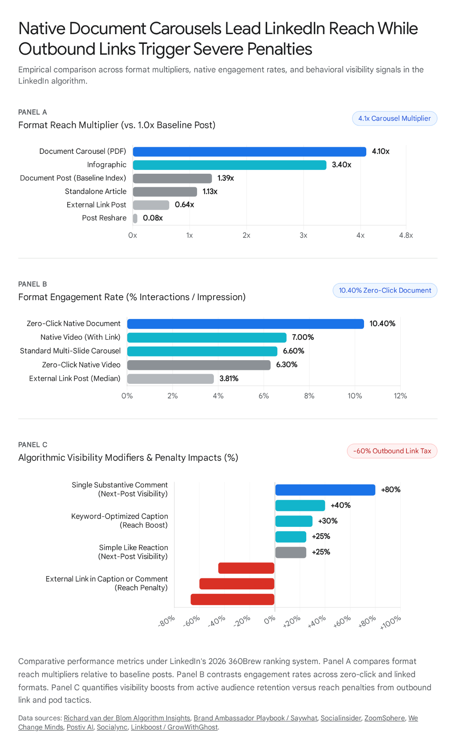
Empirical platform benchmarks indicate that the PDF document carousel is the highest-performing vehicle for capturing the 360Brew Depth Score¹. Because a document requires active horizontal swiping across sequential frames, it mechanically extends session duration and generates a 4.1x reach multiplier alongside a 6.60% to 10.40% engagement rate¹. By contrast, infographics generate a 3.4x multiplier, standalone articles yield a 1.13x multiplier (+13.1% reach with 6.5x more AI citations), and simple reshares return an almost negligible 0.08x multiplier⁶. Achieving maximum organic distribution requires aligning the document's structure with the specific ranking weights of the current algorithm, as detailed in the comparison below.

Algorithmic Dimension | Legacy LinkedIn System (Pre-2026) | 360Brew AI Ranking System (2026 Standard) | Strategic Implication for AEC & BIM Creators
Core Architecture | Chain of separate models evaluating isolated signals (likes, clicks, proximity)¹. | Unified foundation model evaluating semantic depth and behavioral retention¹. | Surface likes no longer trigger broad viral distribution; posts must sustain reading duration³.
Distribution Graph | Relationship and network broadcast graph⁴. | Semantic interest-based precision graph via Topic Fingerprinting⁴. | Content and daily comments must stay strictly anchored to BIM, Revit, and AEC automation⁴.
Primary Quality Metric | Raw engagement volume and early reaction velocity¹. | Composite Depth Score: Dwell Time, Saves, DM Sends, and Threaded Comments³. | Carousels must function as saveable reference cheat sheets rather than disposable teasers³.
Outbound Link Handling | Moderate suppression in post body; easily bypassed via first-comment links⁹. | Severe 40%–60% reach penalty in body; first-comment link hack patched and penalized³. | Video links must be removed from captions and immediate first comments in favor of Zero-Click delivery³.
Profile vs. Page Weight | Company pages retained moderate organic visibility². | Personal profiles generate 5x more engagement; company pages sit below 2.1% of feed¹. | All technical carousels must originate from a personal practitioner profile with human visual branding¹.
Optimal Cadence | High-frequency posting (5 to 6 times per week)⁴. | Consolidated high-depth publishing (2 to 4 times per week)⁴. | Fewer, higher-density assets prevent audience fatigue and maximize per-post algorithmic testing⁴.
A critical second-order consequence of the 360Brew interest graph is how a creator's outbound commenting behavior shapes inbound reach⁴. When an AEC specialist comments on generic, non-technical viral posts, the algorithm's topic fingerprinting classifier registers a diluted domain signal, which weakens the precision matching of the creator's subsequent BIM publications⁴. Conversely, dedicating 25 to 30 minutes daily to writing substantive, multi-sentence technical comments on posts published by fellow BIM Managers, architectural technologists, and construction directors reinforces the account's semantic fingerprint while triggering an 80% boost in the probability that those specific peers see the creator's next carousel⁴.

Diagnosing Low Engagement in Technical BIM Video-to-PDF Workflows
When a technical practitioner records a weekly tutorial video on Revit, Dynamo, or Python automation and publishes a companion PDF explaining every step of the video, low engagement rarely stems from a lack of engineering value. Instead, underperformance is the direct mathematical result of three structural friction points that violate platform mechanics and mobile reading psychology.

The Outbound Link Tax and the Patched First-Comment Workaround
When a PDF carousel is treated as an accompaniment to an external video—such as a YouTube tutorial or external training portal—creators frequently include the video URL in the post caption or direct readers to a link dropped immediately in the first comment⁹. LinkedIn's business model depends on maximizing on-platform session time to serve impressions; consequently, posts containing external links in the caption suffer an immediate 40% to 60% distribution penalty, reducing median engagement to 3.81% and depressing the format multiplier to 0.64². Furthermore, in early 2026, LinkedIn's engineering team closed the "Link in the First Comment" loophole³. The 360Brew classifier scans the comment section during the initial publication window, detects author-dropped links ("bridge behavior"), actively hides bare URL comments from feed view, and applies a reach penalty of up to 45% to 60%—virtually identical to placing the link in the main body³.

The Documentation Trap Versus Zero-Click Content
Translating a technical video by documenting every single click, parameter setup, and code line turns a LinkedIn carousel into an exhaustive software manual. On social feeds, dense procedural manuals underperform because they violate the core tenets of Zero-Click Content—a paradigm formalized by Amanda Natividad and Rand Fishkin in which a post delivers complete, standalone architectural value directly inside the native feed without requiring an external click or zoom interaction⁷. If a PDF carousel reads like an incomplete transcript that requires watching an external video to understand the payoff, readers abandon the swipe sequence early⁷. Conversely, if it packs every microscopic step of a 15-minute Revit workflow onto dense slides, it triggers cognitive overload and becomes a swipe-exit trigger²³. Zero-click native documents achieve a 10.40% engagement rate precisely because they distill a complex workflow into an immediately digestible, self-contained mental model or reference cheat sheet⁷. By delivering standalone insights in the feed, the creator accrues "algorithmic capital" with both the audience and the ranking system, which can then be spent selectively when promoting major launches²⁴.

Mobile Illegibility of Raw AEC Software Interfaces
Over 60% of LinkedIn browsing occurs on mobile devices with 6-inch screens¹⁴. A widespread mistake in AEC content creation is pasting full-screen 16:9 Revit user-interface screenshots, uncropped schedules, or sprawling 25-node Dynamo graphs directly onto carousel slides. When scaled down to a mobile viewport, 8-point node titles and grey-on-grey wire connectors become entirely illegible²³. Rather than pinching and zooming across ten consecutive slides, the mobile user scrolls past²³. In the 360Brew system, an early swipe abandonment during the "Golden Hour"—the first 60 to 90 minutes when the algorithm tests the post on a micro-cohort of active followers—signals low content satisfaction and halts secondary ring distribution⁵.

The Strategic Fix: Decoupling Video and PDF into a Dual-Asset Weekly Cadence
Rather than forcing one post to serve as both a PDF manual and a video traffic driver, the practitioner should split each weekly recording into two separate, platform-native publications separated by 48 to 72 hours, aligning with the optimal 2-to-4-post weekly cadence⁴. The first weekly publication should be a native vertical video teaser formatted in a 9:16 vertical aspect ratio (1080 × 1920 px) running 30 to 90 seconds, displaying the before-and-after automation execution inside Revit within the first 5 seconds alongside burned-in captions¹⁵. LinkedIn's dedicated vertical video feed distributes 15-to-90-second native vertical clips to non-followers at 5x to 10x the rate of standard text posts, while sub-60-second clips earn roughly 53% more engagement than longer recordings¹⁸. Notably, native video is the single format on LinkedIn that performs stronger with an accompanying link (7.00% engagement) than without (6.30%)⁷. Forty-eight hours later, the practitioner should publish the second asset: an 8-to-10-slide 4:5 portrait PDF carousel that deconstructs the conceptual logic, node architecture, and return on investment of that same automation as a standalone, zero-click reference guide with zero outbound links in the caption⁷.

Empirical Evaluation of the Cover Slide: Human Face, Visual Hierarchy, and Hook Mechanics
The hypothesis that adding a personal photograph to the front page of the PDF carousel will increase engagement is empirically supported by behavioral and platform data, provided the visual execution adheres to strict compositional rules¹⁴.

Why a Human Face on Slide 1 Drives Thumb-Stop Velocity
In a B2B feed saturated with generic corporate graphics and unedited artificial intelligence text, human neurobiology is hardwired to arrest eye movement upon detecting a human face¹. Platform testing confirms that carousels featuring the creator's portrait on the cover slide achieve measurably higher initial dwell times and swipe-initiation rates than anonymous title cards³¹. Furthermore, because LinkedIn structurally suppresses company pages (under 2.1% of feed volume) in favor of individual voices (5x higher engagement), anchoring a technical BIM deck with a recognizable human face builds cumulative parasocial trust across weekly installments¹. Over time, AEC peers browsing their feeds recognize the creator's portrait and signature color palette before reading a single word, creating a habitual swipe reflex²⁶.

Compositional Rules for the Cover Portrait
While including a face on Slide 1 is high-leverage, improper sizing or placement can sabotage the cover's primary function. The cover slide performs 80% of the work in determining post performance and has less than 1 to 2 seconds to communicate a tangible content promise¹⁴. To maximize conversion without cluttering the hook, the creator should utilize a precision background removal tool to place a clean, high-resolution shoulder-up portrait cutout with a subtle rim light, or position a framed circular avatar paired with the creator's name and specialized title¹⁴. This portrait must act as a trust anchor rather than a full-bleed lifestyle photograph, occupying roughly 15% to 25% of the canvas so that it does not compress the space required for large, mobile-readable typography and the technical visual hook²³. Spatially, the portrait should sit in the lower-left or middle-left zone—maintaining at least 80 to 100 pixels of clearance from the bottom and left edges—or centered below the primary headline, ensuring the face never collides with the bottom-right "Swipe →" directional cue or LinkedIn's native mobile UI overlays¹⁰. Finally, because plain white cover slides blend into LinkedIn's white mobile interface and disappear during rapid scrolling, the portrait and typography must sit against a dark, high-contrast background color (such as deep architectural navy, charcoal slate, or matte black) paired with crisp white primary text and a single electric accent hue (such as gold, cyan, or vibrant orange) to emphasize the core metric in the headline¹⁴.

Engineering the Cover Headline for AEC Personas
A portrait stops the thumb, but the headline earns the swipe¹⁰. Cover headlines that state a generic software topic—such as "Revit Dynamo Script for Room Tagging" or "Weekly BIM Process Guide"—consistently fail because they describe a procedural topic rather than a quantified professional outcome¹⁴. Leading AEC educators and software specialists—such as Nicolas Catellier at BIM Pure (formerly Revit Pure), Gavin Crump at Aussie BIM Guru, Jeffrey A. Pinheiro at The Revit Kid, and the development teams behind DiRoots and pyRevit—capture practitioner attention by framing every tutorial around the elimination of repetitive production bottlenecks, model corruption risks, or commercial licensing overhead³².
To replicate this framing, the cover headline must be restricted to 5 to 8 words (never exceeding two short lines), set at 48 pt to 72 pt, and structured around a specific number, a contrarian industry claim, or a "How to do X without Y" promise that reads like a high-intent practitioner query²³.

AEC Target Persona | Core Daily Pain Point | Weak Topic Headline (Low Swipe Rate) | High-Converting Outcome Headline (High Swipe Rate)
BIM Manager / Coordinator | Model bloat, hundreds of unresolved warnings, manual QA/QC audits³⁴. | How to Manage Revit Warnings with pyRevit | Isolate 500+ Critical Revit Warnings in 30 Seconds  [cite: 34]
Project Architect / Designer | Tedious sheet setup, manual room/door renumbering, deadline crunches³⁴. | Dynamo Tutorial: Renumbering Doors and Rooms | Renumber 400 Revit Doors Without Touching a Schedule  [cite: 38]
MEP / Structural Engineer | Late clash detection, parameter mismatches across linked models³⁴. | Using Python for Clash Detection and Parameters | The 4-Node Script That Eliminates MEP Parameter Clashes  [cite: 34, 39]
AEC Digital Practice Director | High commercial plugin license costs (€60–$7,000/yr), unstandardized workflows³⁴. | Free Alternatives to Paid Revit Add-Ins | Replace 3 Paid Revit Plugins With 1 Open-Source Script  [cite: 34, 35]

Mobile-First Visual Engineering, Safe Zones, and Node Abstraction
Designing a technical carousel requires shifting from a desktop presentation mindset (16:9 widescreen slides) to a vertical mobile flashcard architecture²³. When a PDF is uploaded via LinkedIn's document tool, the platform locks the entire deck to the aspect ratio of Slide 1 and scales each page to fit the mobile feed viewport³⁰.

Dimensional Physics and Mobile UI Safe Zones
The optimal canvas specification for organic LinkedIn carousels in 2026 is 1080 × 1350 pixels (4:5 portrait aspect ratio)¹⁰. Compared to a 1:1 square (1080 × 1080 px), which remains mandatory only for paid Carousel Ads, the 4:5 vertical frame occupies 25% more vertical screen space on mobile devices, pushing competing feed posts out of view and increasing reader immersion¹⁰.
However, LinkedIn's mobile interface overlays several persistent UI elements directly on top of the document canvas: the author header and caption preview sit above the top edge, a translucent page-counter badge and swipe indicator overlay the bottom edge of Slide 1, and interaction controls (Like, Comment, Share) sit along the bottom perimeter, particularly obstructing the bottom-right quadrant¹⁴. Consequently, strict adherence to an 80 px to 100 px perimeter safe zone—keeping all headlines, node callouts, and portraits inside the central 880 × 1150 px core area—is essential to prevent clipping across devices¹⁰.
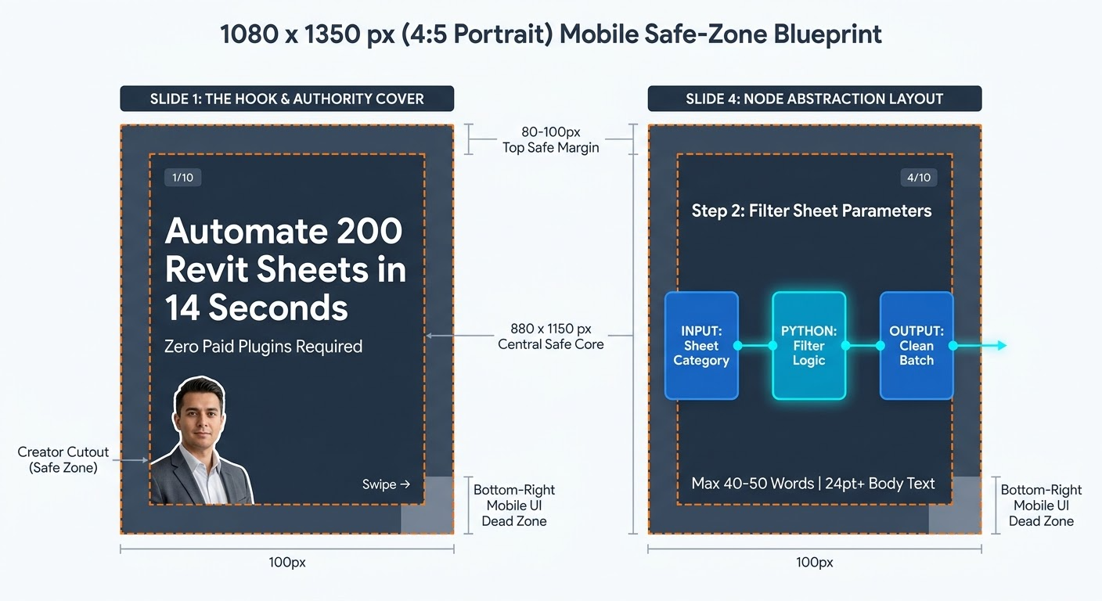

The Flashcard Principle and Typography Thresholds
Empirical retention analysis demonstrates that restricting each carousel slide to one core idea—the flashcard principle—increases post dwell time by 20% to 30%²³. If a single step in a Revit or Dynamo workflow requires more than two to three short sentences of explanation, that step must be split across two consecutive slides²³. Furthermore, every cover and internal slide must pass the "Squint Test" at thumbnail scale (approximately 270 × 340 px), ensuring the focal point and headline remain identifiable even when blurred²³. All layout templates should be duplicated from the first content slide so that font sizes, color blocks, and spatial hierarchy remain identical across the entire deck, varying only the modular content inside each frame²³.

Design Parameter | Mandatory Specification | Behavioral & Algorithmic Justification
Canvas Dimensions | 1080 × 1350 px (4:5 Portrait)¹⁰ | Captures 25% more vertical mobile screen area than 1:1 square; prevents mixed-ratio cropping³⁰.
Optimal Slide Count | 8 to 12 Slides (Hard range: 7–15)³¹ | Fewer than 5 slides feels thin; beyond 15 slides triggers steep reader drop-off³⁰.
Perimeter Safe Margin | 80 px to 100 px on all four sides¹⁰ | Prevents mobile header clipping, bottom-edge swipe overlay collision, and right-corner UI obstruction¹⁴.
Headline Font Size | 48 pt to 64 pt (Bold Sans-Serif)²³ | Ensures instant legibility on 6-inch mobile displays without zooming¹⁴.
Body Copy Font Size | 24 pt to 32 pt (1.4x–1.6x line height)²³ | Over 60% of sessions are mobile; text below 20 pt triggers immediate swipe exits²³.
Copy Density Cap | Max 40 to 50 words (2–4 lines per slide)²⁶ | Keeps cognitive load low; 35–45 characters per line optimizes rapid scanning²³.
Color Contrast Ratio | Minimum 4.5:1 (Background to Text)³⁷ | One dark background, one crisp white/light-gray text color, one high-contrast accent color¹⁴.
PDF Export Standard | Under 3 MB, Vector-First PDF (sRGB)³⁰ | Files under 3 MB load instantaneously on mobile cellular networks and avoid LinkedIn compression artifacts³⁰.
Document Upload Title | Keyword-Rich Descriptive Filename  [cite: 43] | Visible in the feed player header; replaces sloppy Final_v2.pdf labels with semantic search keywords⁹.

Translating Complex BIM, Dynamo, and Python Visuals for Mobile
To explain a technical video without losing the reader on Slide 3, raw software screenshots must undergo Visual Node Abstraction. Rather than screenshotting an entire 30-node Dynamo workspace, the creator should group the script into color-coded functional containers—such as Data Extraction, Python List Filtering, and Revit Parameter Write—and zoom in to display only the 2 to 3 pivotal nodes per slide¹⁴. When rasterized graphics are necessary, designing at 2x resolution (2160 × 2700 px) and exporting crisp PNG crops before compiling the final vector PDF ensures parameter names remain sharp without exceeding the 3 MB file size threshold³⁰. Similarly, when presenting Python or pyRevit code, a slide should never contain more than 6 to 8 lines of syntax; boilerplate imports (such as clr.AddReference('RevitAPI')) should be dimmed or omitted while the exact 2 lines performing the transaction or filtering logic are highlighted inside a high-contrast accent box accompanied by a plain-English annotation¹⁴.
To reinforce forward swipe momentum across these technical steps, the layout should utilize the panoramic ("seamless") effect by designing across an extended canvas—such as a 10,800 × 1350 px artboard divided into ten 1080 px segments—where node wires, architectural section lines, or directional arrows extend across the right border of Slide onto the left border of Slide 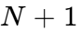¹⁴. This continuous visual bridge compels the practitioner to swipe to inspect the connected output node¹⁴. Additionally, placing a persistent progress indicator (3/10, 4/10) in the upper corner of every internal frame informs busy architects and BIM coordinators of the exact length of the tutorial, preventing premature exits caused by unknown document length²³.

The 10-Slide Narrative Architecture and Lead-Generation Handoff
High-performing technical carousels are not arbitrary collections of tips; they are architecturally sequenced documents where every slide position fulfills a specific psychological and algorithmic role²³. By blending the PIP (Problem, Insight, Playbook) and TEA (Teach, Explain, Apply) zero-click frameworks with classic AIDA (Attention, Interest, Desire, Action) narrative pacing, a 10-slide BIM carousel systematically converts a casual scroller into an engaged connection⁷.
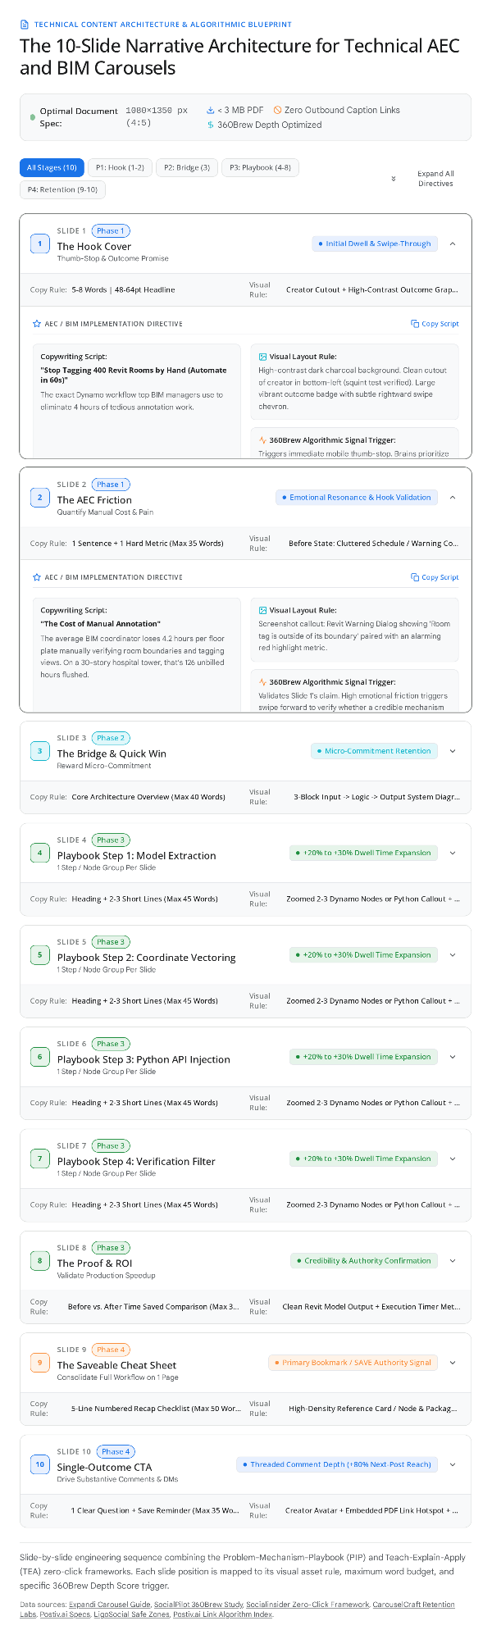

Critical Mechanics of Slide 3, Slide 9, and Slide 10
While Slides 4 through 7 deliver the step-by-step technical tutorial, three structural pivot points govern whether the post achieves deep algorithmic distribution within the AEC niche. The first pivot occurs on Slide 3 (The Bridge), where a viewer who has swiped past the cover and problem framing makes a micro-commitment to the document²³. If Slide 3 wastes attention on creator self-promotion, software version disclaimers, or dense setup prerequisites, the viewer exits¹⁰. Instead, Slide 3 must immediately reward the reader with tangible value by presenting the macro system architecture—mapping the exact input category, required Dynamo packages or open-source tools (such as DiRoots, pyRevit, or Speckle), and output target—so the practitioner grasps the entire workflow before examining individual nodes²³.
The second pivot occurs on Slide 9 (The Saveable Reference Cheat Sheet). Under the 360Brew ranking system, a Save (bookmark) and a DM Send act as premier authority signals, prompting LinkedIn to elevate both metrics directly into native post analytics³. Engineers and architects rarely bookmark a carousel for its hook; they bookmark checklists, parameter mapping tables, and node sequences that they can reference on a second monitor while working inside Revit¹⁰. Designing Slide 9 as a self-contained, five-line numbered recap card that consolidates the entire script architecture and required package list dramatically increases bookmarking velocity¹⁰.
The final pivot occurs on Slide 10 (The Single-Outcome CTA & Embedded Hotspot). Placing three competing instructions on the final slide—such as asking the reader to follow, save, comment, and subscribe to a YouTube channel simultaneously—induces decision paralysis and suppresses conversion³¹. Slide 10 must instead pair a plain instruction to bookmark the asset ("Save this cheat sheet for your next Revit QA/QC audit") with one focused engagement action¹⁰. Crucially, because LinkedIn preserves clickable hyperlinks embedded natively inside a PDF document without triggering the feed caption link penalty, the creator can embed a clean vector button hotspot on Slide 10 pointing directly to the full video tutorial or GitHub repository¹⁷. Because only the most engaged followers who swipe through all ten frames encounter this button, it drives highly qualified external traffic while preserving 100% of the post's native organic reach¹⁷.

Replacing "Link in Comments" with High-Depth Comment and DM Conversion
To capture leads, distribute .dyn or .py script files, and drive video views without triggering the 2026 outbound link penalty or AI-comment spam filters, the caption and post-publication workflow must operate as a synchronized system. The accompanying feed caption should be formatted as a 100-to-200-word narrative frame that opens with a sharp two-line hook above the "…see more" fold, incorporates natural industry keywords (which generate roughly 30% more reach and twice the likes compared to hashtag-stuffed copy), teases the core engineering insight without summarizing every slide, and concludes with an explicit swipe cue⁹. The copy must remain completely free of generic AI openers—such as "In today's fast-paced world"—which are actively flagged and throttled by LinkedIn's natural language processing classifiers¹.
Furthermore, while prompting readers to "Comment 'SCRIPT' to receive the file via DM" remains a viable lead-generation mechanism, an influx of identical one-word comments mimics automated engagement pod activity, which carries a 45% reach penalty and risks account shadowbanning⁵. With 80% of early comments on the platform now generated by artificial intelligence bots, 360Brew heavily weights Comment Depth—evaluating whether comments contain substantive multi-line insights and spark threaded replies³. Consequently, the caption CTA should ask a specific architectural or BIM management question alongside the resource offer, such as asking peers whether their firm manages sheet exports via native Revit, pyRevit, or DiRoots ProSheets, and offering to send the raw script and full video breakdown to anyone who shares their workflow³.
During the first 60 to 90 minutes after publishing—the Golden Hour testing phase—the creator must actively reply to every incoming comment with a multi-sentence technical follow-up³. Top 1% LinkedIn creators reply to comments 741% more frequently than average creators, multiplying conversation depth and propelling the post into secondary distribution rings³. If an external link to the weekly video must be shared publicly in the thread, it should never be posted as a bare URL immediately upon publication; instead, the creator should wait until organic discussion is underway and post a thoughtful, multi-sentence comment that provides an extra technical insight (such as an API limitation or Revit 2026 compatibility note) with the URL included as a contextual footnote, or direct readers to the permanent link housed in the personal profile's Featured Section³.

Master Reference Specification for Automated Slide Creation and Prompt Attachment
The following consolidated specification is structured as a permanent reference rulebook. Attaching this section to any future slide-creation prompt alongside a raw weekly video transcript will instruct the workflow to generate a mobile-optimized, algorithmically compliant 10-slide BIM carousel.

Part 1: Hard Technical and Visual Production Constraints

Specification Category | Strict Rule for Every Carousel Asset
Target Audience & Domain | BIM Managers, BIM Coordinators, Project Architects, MEP/Structural Engineers, Computational Designers, and AEC Consultants⁵.
Canvas & Aspect Ratio | 1080 × 1350 px (4:5 Portrait) across all slides; export as a single vector-first PDF under 3 MB in sRGB color space¹⁰.
Perimeter Safe Zones | Maintain 80 px to 100 px clear margin on all edges (central 880 × 1150 px safe zone). Keep bottom-right corner clear of critical text¹⁰.
Slide Count & Density | 8 to 10 slides total. Strictly 1 idea per slide, 2 to 4 lines of body text, 35 to 45 characters per line, and maximum 40 to 50 words per slide²³.
Typography & Color System | Dark high-contrast background (Navy/Charcoal), White/Light-Gray body text (24 pt–32 pt), Bold Headlines (48 pt–64 pt), and 1 electric accent color for keywords and metrics (minimum 4.5:1 contrast)¹⁴.
Cover Slide (Slide 1) Rules | Include a background-removed portrait cutout of the creator in the lower-left or middle-left safe zone (15%–25% canvas area), a 5-to-8-word outcome-driven headline (quantifying time saved, errors prevented, or plugins replaced), and a subtle "Swipe →" cue¹⁴.
Software Visual Abstraction | Never use full-screen 16:9 Revit screenshots or entire Dynamo workspaces. Crop and zoom into 2 to 3 key nodes per slide or 6 to 8 lines of Python code with high-contrast callout boxes and panoramic arrows connecting across slide borders¹⁴.
Document Upload Filename | Name the PDF file using a clean, keyword-rich title (e.g., Revit-Sheet-Automation-Dynamo-Playbook.pdf) prior to upload⁹.

Part 2: Slide-by-Slide Content Generation Template (Video Transcript to Carousel)
When converting a weekly BIM, Revit, or scripting video transcript into slide copy, all slide text must be drafted prior to visual layout using the 10-slide structural mapping below²³:

Slide # | Structural Role | Copywriting & Visual Extraction Directive from Video Transcript | Word Cap
Slide 1 | The Hook Cover | Extract the ultimate time-saving or error-eliminating payoff of the video. Write a bold 5–8 word headline starting with a metric or verb + 1 short promise sub-line. Include creator portrait cutout and "1/10" counter²³. | 15 words
Slide 2 | The AEC Problem & Stakes | State the specific manual Revit/BIM bottleneck in one sharp sentence, backed by one concrete cost/time number (e.g., hours lost per project or model corruption risk)¹⁴. | 35 words
Slide 3 | The Architectural Bridge | Deliver immediate value by presenting the 3-part macro workflow (Input → Script/Node Logic → Revit Output) and listing any required packages or tools (e.g., pyRevit, Dynamo, Python)²³. | 40 words
Slide 4 | Step 1: Data Input / Selection | Explain how elements or parameters are collected in Revit. Show a zoomed visual of the selection node or collector code block²³. | 45 words
Slide 5 | Step 2: Core Filtering Logic | Explain how the data is cleaned, sorted, or structured. Highlight the exact list-management node or boolean filter²³. | 45 words
Slide 6 | Step 3: The Transformation Engine | Detail the core automation action (e.g., Python API transaction, geometry generation, or parameter overwrite) with a highlighted code/node callout²³. | 45 words
Slide 7 | Step 4: Execution & Error Handling | Show how the script handles edge cases, warnings, or batch execution across sheets/families²³. | 45 words
Slide 8 | The Proof & ROI Comparison | Contrast the manual workflow duration against the automated execution time (e.g., Manual: 3.5 Hours vs. Script: 8 Seconds) with a clean visual of the finished Revit deliverable¹⁴. | 35 words
Slide 9 | The Saveable Cheat Sheet | Summarize the entire 4-step workflow and package checklist into a 5-line numbered reference list designed to be bookmarked for daily production use¹⁰. | 50 words
Slide 10 | Single-Outcome CTA | Instruct the reader to Save the deck for their next project, provide an embedded PDF link button to the video/repo, and ask one specific technical question to spark comments¹⁰. | 35 words

Part 3: Feed Caption and Post-Publication Execution Protocol

Execution Stage | Mandatory Action Protocol
Caption Hook (Lines 1–2) | Open with a contrarian statement, painful AEC project scenario, or hard metric so the reader clicks "…see more"²⁶.
Caption Body (100–200 Words) | Frame why this BIM workflow matters for project profitability or model health using short 1–2 sentence paragraphs and native industry keywords. Do not summarize every slide, and never place an external URL in the caption⁹.
Caption Call-to-Action | End with a swipe directive ("Swipe through the 10-slide blueprint below ↓") followed by an open-ended technical question inviting peers to share their current workflow and request the .dyn/.py script + video walkthrough via DM⁹.
Golden Hour Engagement | Reply to all comments within the first 60–90 minutes using multi-sentence technical responses to maximize the 360Brew Depth Score³. Spend 25–30 minutes commenting on peer AEC/BIM posts to lock in the account's topic fingerprint⁴.

Strategic Conclusions
Maximizing engagement on technical BIM and Revit carousels under LinkedIn's 360Brew ranking regime requires transitioning from procedural video documentation to standalone, zero-click visual engineering³. By decoupling the weekly video into a native 9:16 vertical clip and a link-free 1080 × 1350 px PDF carousel, the practitioner eliminates the 60% outbound link penalty while capturing the 4.1x reach multiplier and 10.40% engagement rate afforded to native documents⁶. Anchoring Slide 1 with a clean portrait cutout and an outcome-driven headline arrests scroll velocity, while abstracting dense Dynamo graphs and Python scripts into 24 pt+, single-idea flashcards sustains mobile dwell time through Slide 9's bookmarkable cheat sheet and Slide 10's embedded link hotspot¹⁰. Paired with substantive Golden Hour comment threads and disciplined daily engagement within the AEC interest graph, this architecture transforms weekly technical tutorials into a compounding authority and lead-generation engine³.

Works cited
- LinkedIn Algorithm 2026: How It Ranks Posts and Why Your Reach, https://www.zoomsphere.com/blog/linkedin-algorithm-2026-why-generic-ai-content-kills-your-organic-reach
- LinkedIn Algorithm Insights: Oct 2025 | PDF - Scribd, https://www.scribd.com/document/946320519/LinkedIn-October-Algorithm-Report-2025
- How the LinkedIn Algorithm Works: September 2026 Update, https://www.socialpilot.co/blog/linkedin-algorithm
- Richard van der Blom — The state of LinkedIn in 2026 (based on, https://creatorscience.com/podcast/richard-van-der-blom-2/
- How to Fix Low LinkedIn Engagement in 2026 (Algorithm Guide), https://www.linkboost.co/blog/fix-low-linkedin-engagement-2026/
- Brand Ambassador Playbook - LadyBugz Marketing, https://www.ladybugz.co.za/brand-ambassador-playbook/
- Zero-Click Content vs. Links: LinkedIn & Facebook Data - Socialinsider, https://www.socialinsider.io/blog/zero-click-content/
- LinkedIn Carousel Posts: Specs, Steps And Examples - SocialPilot, https://www.socialpilot.co/blog/linkedin-carousel
- Should You Put Links in Captions or First Comment? - Socialync, https://www.socialync.io/blog/links-in-captions-vs-first-comment-2026
- LinkedIn Carousel Size: Dimensions & Safe Zones - LigoSocial, https://ligosocial.com/blog/linkedin-carousel-post-size-guide-2025-dimensions-formats-and-best-practices
- How to Post a Link on LinkedIn (Without Killing Your Reach), https://linkedinpreview.com/blog/how-to-post-a-link-on-linkedin
- LinkedIn Algorithm 2026: Why External Links Reduce Reach, https://www.wechangeminds.com/the-linkedin-link-tax/
- LinkedIn Algorithm Changes 2026: Beat the Depth Score - Linkboost, https://www.linkboost.co/blog/linkedin-algorithm-changes-2026/
- 10 Unbeatable Tips to Create a Carousel That Dominates Social, https://carouselcraft.io/en/blog/10-unbeatable-tips-to-create-a-carousel-that-dominates-social-media
- Mastering the LinkedIn Algorithm in 2025/26 - - The Lone Recruiter, https://thelonerecruiter.com/wp-content/uploads/2025/10/Mastering-the-LinkedIn-Algorithm-in-202526-.pdf
- LinkedIn Algorithm Insights 2025 Report | PDF | Linked In - Scribd, https://www.scribd.com/document/984921783/Algorithm-Insights-Report-2025-chapter-1-Richard-Van-der-Blom
- How to Post a Link on LinkedIn Without Killing Your Reach (2026), https://postiv.ai/blog/how-to-post-a-link-on-linkedin
- LinkedIn Algorithm 2026: Latest Updates, Changes & How It Works, https://www.viralbrain.ai/guides/linkedin-algorithm-2026
- Zero-Click Content: What It Is and Why You Should Create It, https://blog.hootsuite.com/zero-click-content/
- Zero-Click Content: Key to LinkedIn Engagement for B2B Healthcare, https://ahamediagroup.com/blog/zero-click-b2b-linkedin-engagement/
- Zero-Click Content: The Counterintuitive Way to Succeed in a, https://sparktoro.com/blog/zero-click-content-the-counterintuitive-way-to-succeed-in-a-platform-native-world/
- About Amanda Natividad — Zero Click Marketing, https://zeroclickmarketing.co/about
- Instagram Carousel Design: Complete Guide to Swipe Worthy Posts, https://futuristicmarketingservices.com/Blogs/graphic-designing/instagram-carousel-design-guide/
- Zero-Click Content & ROI: The Future of Marketing - Databox, https://databox.com/zero-click-content-future-roi
- LinkedIn carousel best practices for B2B in 2026 - Oktopost, https://www.oktopost.com/blog/linkedin-carousel-pdf-best-practices/
- How to Create a Carousel Post on LinkedIn: Step-By-Step Guide, https://www.supergrow.ai/blog/how-to-create-carousel-post-linkedin
- How To Create A LinkedIn Carousel In 2026 [Examples + Tutorials], https://expandi.io/blog/linkedin-carousel/
- Linkedin Content (Grade A) - Claude Skill - Skills Directory, https://www.skillsdirectory.com/skills/ericrisco-linkedin-content
- Viral LinkedIn Post Optimization Guide | PDF | Applied Mathematics, https://www.scribd.com/document/952656273/Gpt-Builder-Document
- LinkedIn Aspect Ratios & Image Sizes in 2026: Feed, Video, Ads, https://posteverywhere.ai/blog/linkedin-aspect-ratios
- 14 Best LinkedIn Carousel Makers in 2026 (Free & Paid, Tested), https://postiv.ai/blog/best-linkedin-carousel-makers
- Top 12 YouTube Channels to learn Revit: Free tutorials - RD Studio, https://rdstudio.co/blogs/news/top-10-youtube-channels-to-learn-revit
- Best YouTube Channels, Courses & Communities to Learn BIM 360, https://www.novatr.com/blog/best-resources-to-learn-bim-360
- 12 Amazing Revit Plugins All BIM Managers Should Use, https://www.bimpure.com/blog/12-amazing-revit-plugins-all-bim-managers-should-use
- DiRootsOne Alternatives for Architects and BIM Managers - ArchiLabs, https://archilabs.ai/posts/dirootsone-alternatives
- Best 10 YouTube Channels to Learn Dynamo for Revit | RD Studio, https://rdstudio.co/blogs/news/best-youtube-channels-to-learn-dynamo-for-revit
- LinkedIn Carousel Dimensions 2026: Size, Specs & Format Guide, https://postiv.ai/blog/linkedin-carousel-size
- Renumbering in Revit: It's Easy...and It's Free - YouTube, https://www.youtube.com/watch?v=Qp8OCGPx_0s
- Late-stage clashes can mean redesign, rework, delays, and on-site, https://www.facebook.com/DraftechMEPSolutions/posts/clashes-are-inevitablethe-cost-of-finding-them-too-late-doesnt-have-to-bethe-pro/1825691315743911/
- LinkedIn Carousel Size Guide 2026: Dimensions, Format & Specs, https://carouselpost.io/guides/linkedin-carousel-size-guide
- Instagram Carousel Size in 2026: Exact Dimensions, Aspect Ratios, https://www.krumzi.com/blog/instagram-carousel-size-guide
- Carousel Posts on LinkedIn: How to Get 3.7x More Engagement in, https://www.omnicreator.club/blog/carousel-posts-on-linkedin-how-to-get-3-7x-more-engagement-in-2026-complete-guide/
- How to Post a Carousel on LinkedIn the Right… - ViralBrain, https://www.viralbrain.ai/blog/how-to-post-a-carousel-on-linkedin
- LinkedIn Carousel Size: 1080x1350, Templates & How to Post, https://linkedgrow.ai/blog/linkedin-carousel-templates
- Nordic Road & Rail collabora on group´s (NBC-group) digitalisa on, https://www.banenor.no/contentassets/45d113ee58714ee99659f3493c2de590/nordic-perspective-on-bim-2025.pdf
- DiRoots FamilyReviser Alternatives for Architects in Revit, https://archilabs.ai/posts/diroots-familyreviser-alternatives
- LinkedIn Carousel Strategy: The 2026 Guide to B2B Engagement, https://digitallybugged.com/linkedin-carousel-strategy-the-ultimate-guide-to-dominating-the-feed-in-2026/
- LinkedIn Carousel Posts: Professional Guide | Gamma.app, https://gamma.app/explore/content/guides/linkedin-carousel-posts-professional-guide
- LinkedIn Carousel Posts for B2B: Best Practices | traxy, https://traxy.ai/blog/linkedin-carousel-posts-b2b-best-practices-2026

